A Concept note for the proposal on

Prevention of stone dust inhalation for stone carvers

# Background

Inhalation of stone dust is a common and severe problem faced by labourers working in stone quarry and stone crushing units. The silica traces present in the stones, if inhaled, can cause a respiratory ailment known as ‘Silicosis’. The disease in its severe form can be fatal and there is no known cure for silicosis till date.

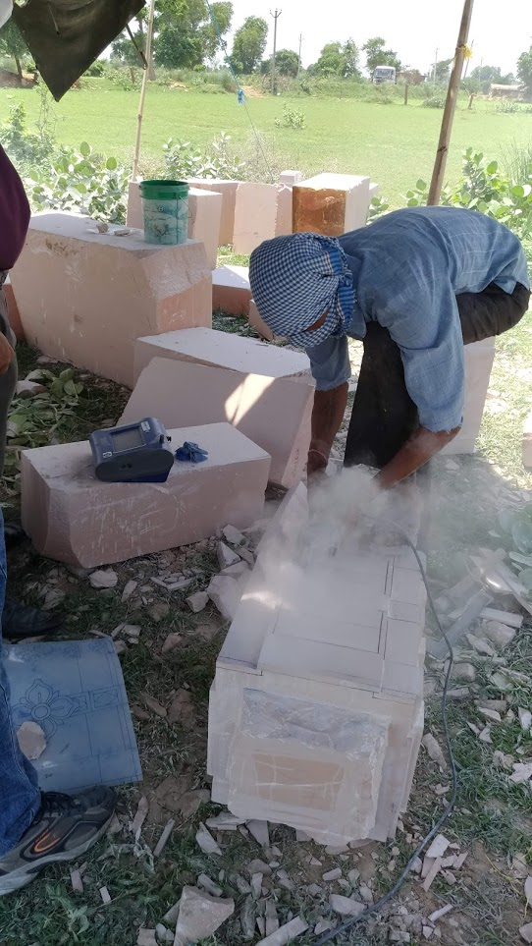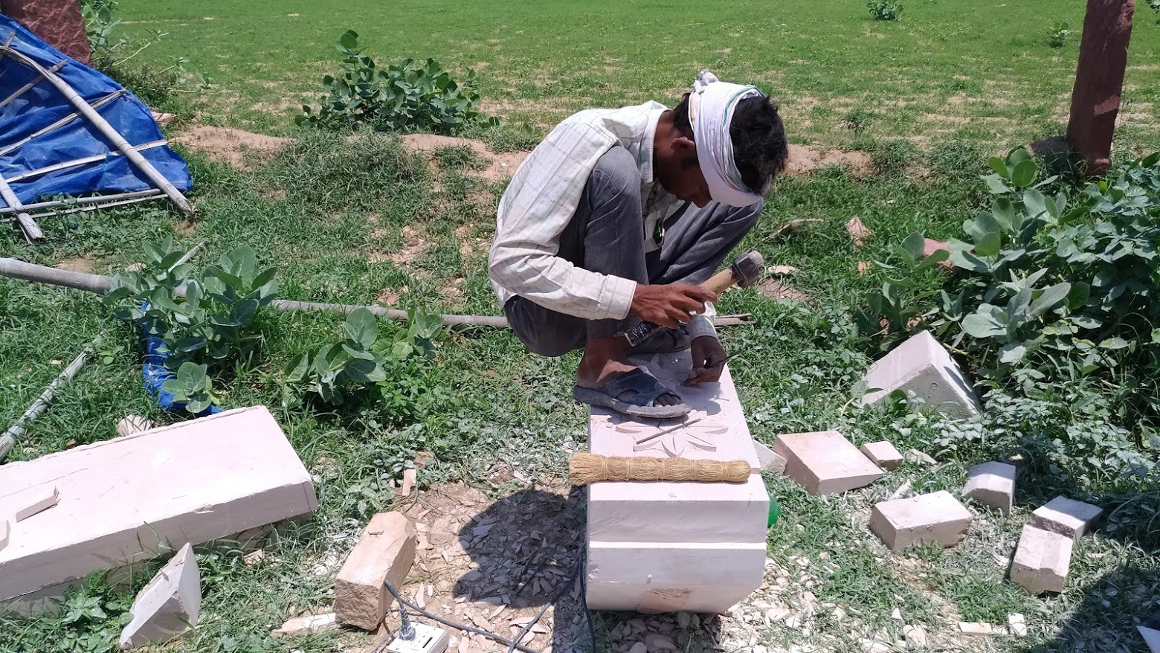Type of stones involved include sandstone and white marble. Stone quarry workers deal with sandstone and the stone carvers work on white marbles. The workers in the unorganized sectors are most affected since they do not have the proper economic and social support to create a safe working environment for themselves. The images below show the stone carving techniques (manual and mechanised) used in a mine near Bharatpur, Rajasthan.

# Preliminary Investigation and Problem Identification

A visit was made to a mine near Bharatpur, Rajasthan, to observe and study the working environment and working process of the stone carvers. The following observations were made in that regard.

* Artisans use both manual and mechanised way to carve the stones based on the applications.
* Particulate measurement devices reported abnormally high amount of particulate matter concentration in the working environment.
* Use of water to supress the dust is not feasible due to severe water shortage.
* P1 Masks are provided by the contractor. Proper maintenance and utilization of the mask is not done.
* Labourers prefer thinner mask since the current mask is bulky and restrictive.
* It was noted that the local government body compensates the artisans who are contracted with silicosis with a sum amount of ₹ 2 Lakhs. This may be one of the causes of observed lack of interest to prevent silicosis among the artisans.

# Preliminary Objectives

Based on the observations, following objectives are formulated.

1. ***A socio-economic study to completely assess the situation:*** A study will be required to completely understand the ground level situation of the artisans. To fulfil this, a socio-economic study will be planned and conducted. The study will be aimed to understand the main reasons that hinder the labourers from using the masks provided, the impact of silicosis on the artisans and the precautions taken up by them to prevent the same.
2. ***Technical solutions to prevent the inhalation:*** Based on the socio-economic study, technical solutions will be developed that can prevent the inhalation of stone dust by the artisans. This may include dust suppression at source, low cost masks, controlled environments, etc., based on the technical and economic feasibility.

# Duration

1 year

# Estimated Budget

₹ 1.5 lakhs

# Field Agency/NGO

* + Lupin Human Welfare and Research Foundation, Bharatpur. Contact Person: Mr. Hemant Sharma
  + Daang Vikas Sansthan, Karauli. Contact Person: Mr. Vikas Bharadwaj.

# Principal Investigators: Dr. Debabrata Dasgupta, Dr. Bahni Ray